Energy

Lesson #1: We Are All Scientists

*Note: Classroom teachers should have already done the pre-test with their students. If so, collect these to give to Jen or Molly. If not, pass out the pre-test to the students before starting the lesson.

Time Frame: 60 minutes

Learning Standards:
Science
Crosscutting Concepts
- Science affects daily life.
- Most scientists and engineers work in teams.

Student will be able to:
- Have an understanding of and feel comfortable using the scientific method.
- Learn that they can be scientists!

Resources and Materials:
Item | Amount
Science Journals
“What is a Scientist” PowerPoint
Bin | 1 (in bin)
Classroom objects (not provided) | (in classroom)
Paper (not provided) | (in classroom)
Drawing utensils (not provided) | (in classroom)
“Steps of the Scientific Method” handout | 25 (in bin)
“Order the Scientific Method” handout | 25 (in bin)

Focus Activity: Introduce yourself to the class, and tell students you will be teaching them all about science. Give students their science journals. Tell them that these journals will be important tools in their scientific exploration. Write on the board "One thing I know about science is..." and ask students to write an answer in their science journals, using a complete sentence. Have students share their answers, and make an idea web around the question on the board.

If students do not mention the word "scientist", ask them who performs scientific experiments. Tell them they will be learning about what and who exactly a scientist is, and how they can be a scientist in their everyday life.

Introduction: Present the “What is a Scientist” PowerPoint. You can find a link for the PowerPoint Presentation on the Center for Learning in Action website at this web address: http://learning-in-action.williams.edu/opportunities/elementary-outreach/science-lessons/4th-grade-energy-unit/ under Energy unit Lesson 1. Tell the students that while there is no "right" way to be a scientist, there are some steps that scientists use in order to do research successfully, called the scientific method. Give students the “Order the Scientific Method” student handout with the descriptions of the steps of the scientific method that are out of order. Students should try to order the steps. Then review the meaning of each step with the students as a class and ask them to discuss and explain what order the steps should be in. After students discuss the order of the scientific method, give each student a copy of the “Steps of the Scientific Method” handout so that students can refer to the steps during the activity and during experiments in future lessons.

Activity:
- Tell students that now they will be scientists and will research a question together, using the scientific method.
- Make sure that you fill the large bin halfway with water and put it off to the side of the classroom before the lesson starts. Ask students to volunteer some questions they can test in the classroom. Tell them they have good suggestions, but that a really simple question that you want to try and that you think will be easy to test is how can we know whether something will sink or float in water? Write this at the top of the board under the heading of Question: Then draw a chart like the one below one the board.

Object | Class Hypothesis |  | Result
 | Sink | Float

- Working with the students, investigate the question of how can we know whether something will sink or float in water. Ask some volunteers for suggestions about what to test. These things should be waterproof things or junk that you can easily find in the classroom. Before testing each object, have students confer as a class about whether they think it will sink or float. If time allows, you can have students try to persuade their classmates of their opinions. Regardless, keep a tally on the board of whether the class thinks the object will sink or float. Test the object. Then record your results on the board. (If there is time: As you do more trials, try to come up with 1 model or rule to answer the question. Then test more things, following your rule, to see if your rule works. Refine your model or rule if necessary.)

Closure: Have students draw a self-portrait. Then have them write “I, (insert name), am a scientist” on the sheet. Students should write something they learned about being a scientist on the sheet. After class, hang these up in the classroom with your classroom teacher’s help.

Assessment: participation, science notebooks, self-portrait

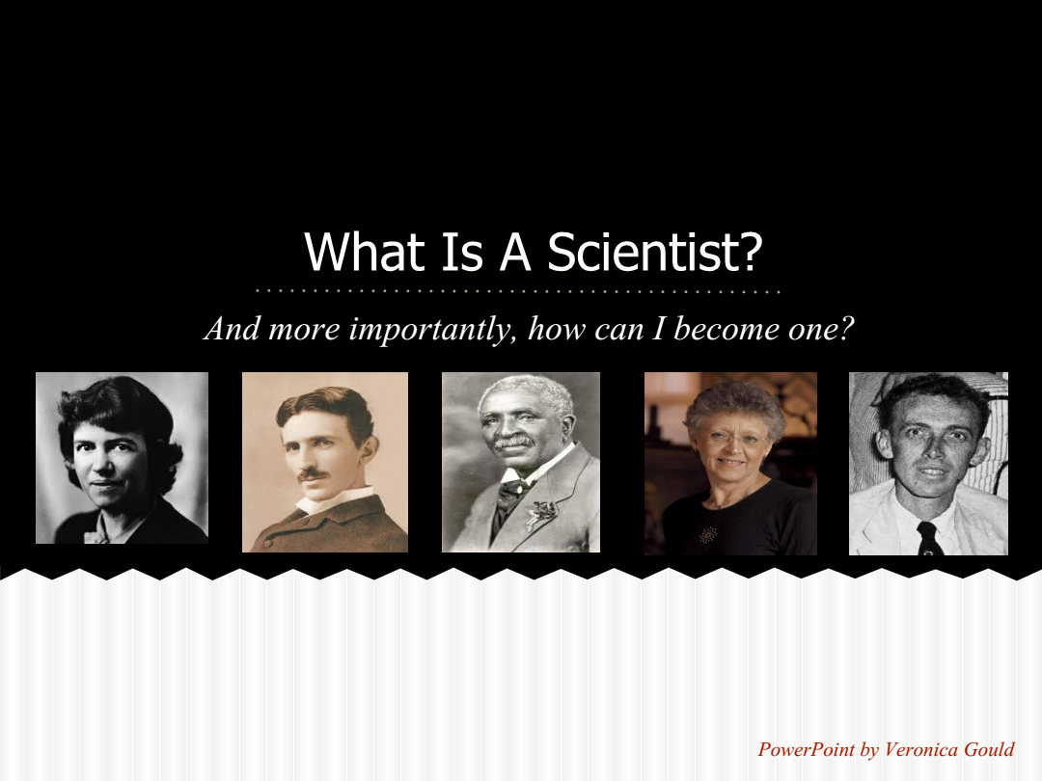
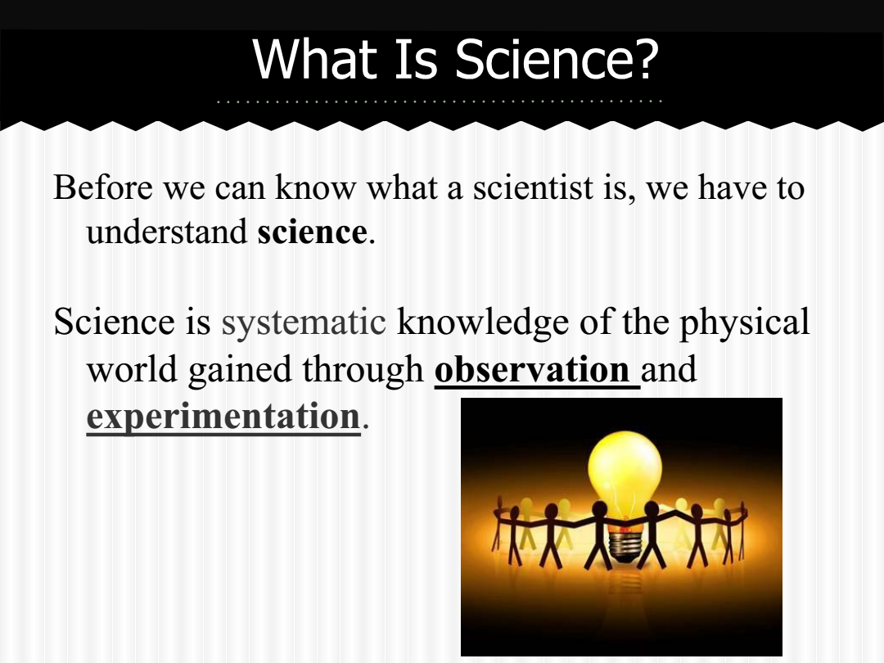
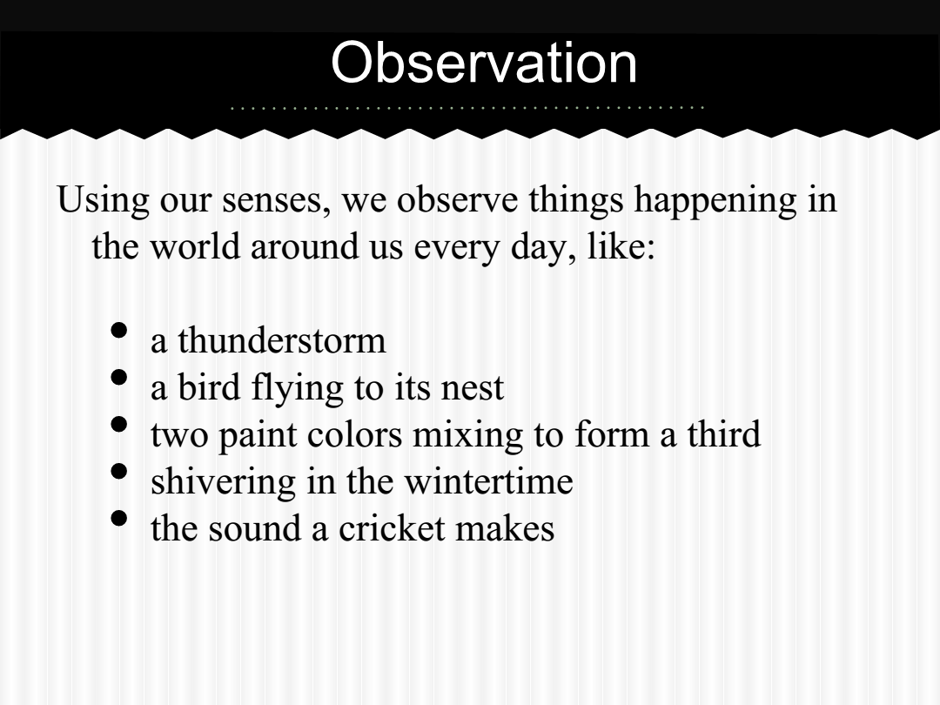
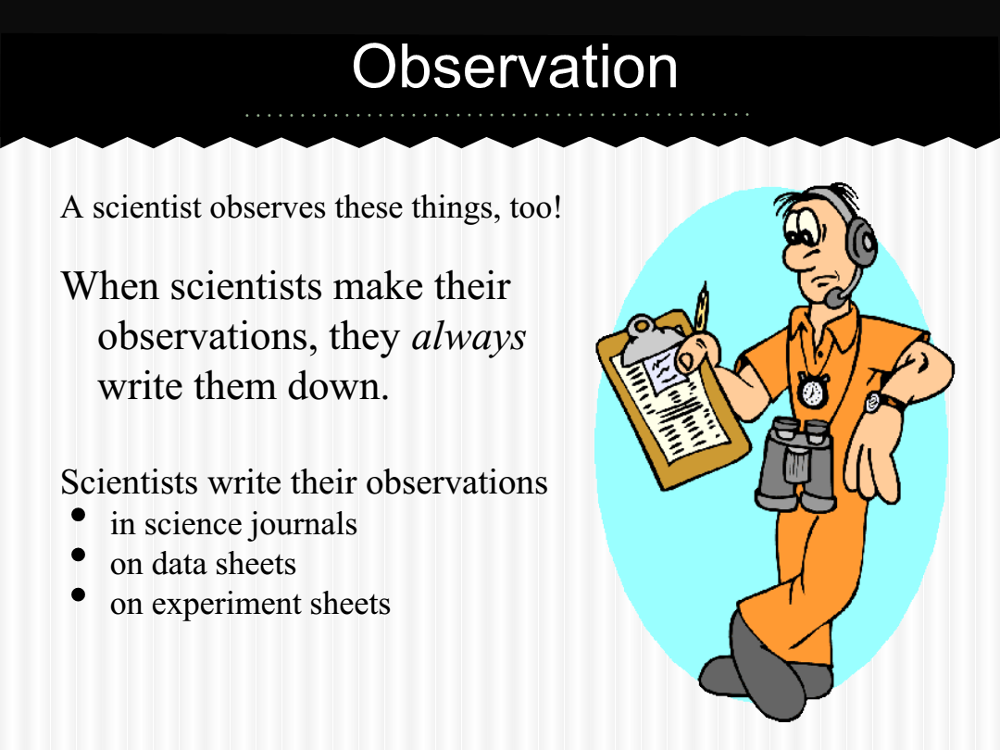
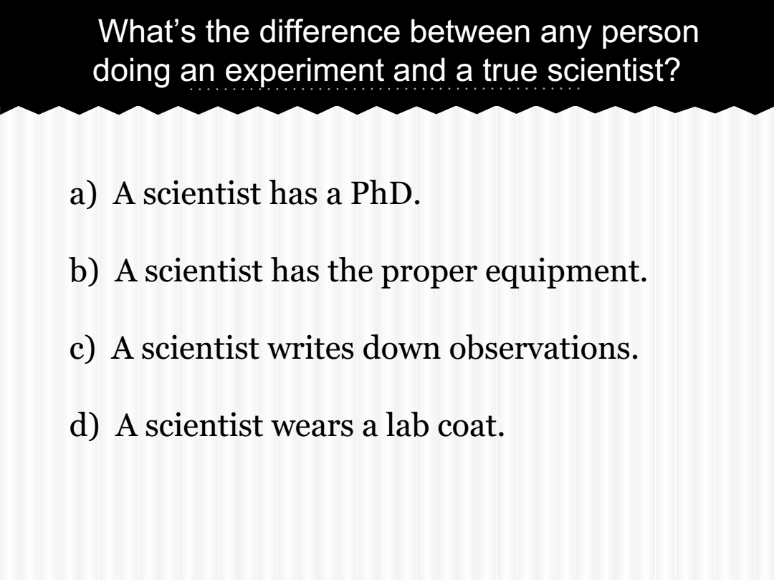
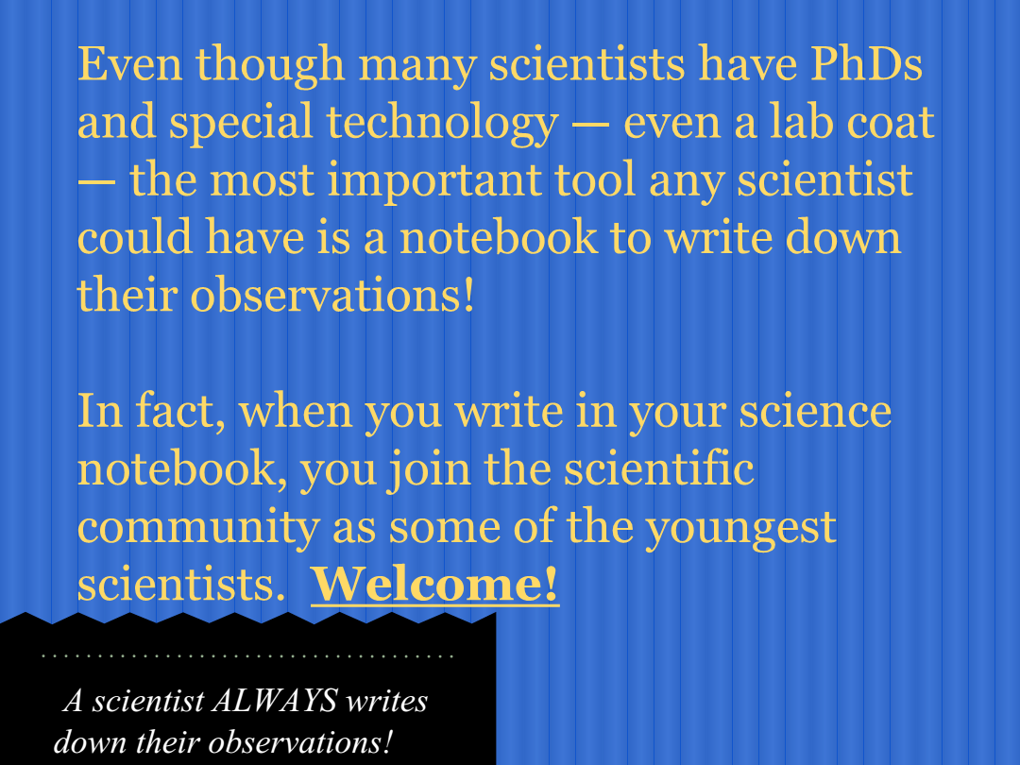
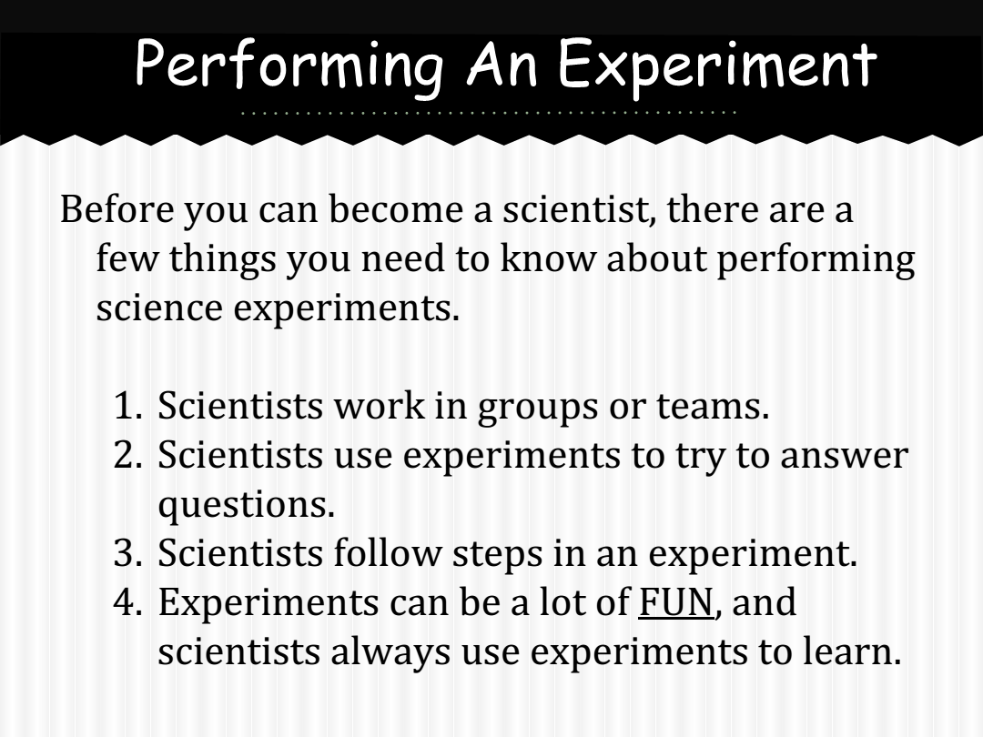
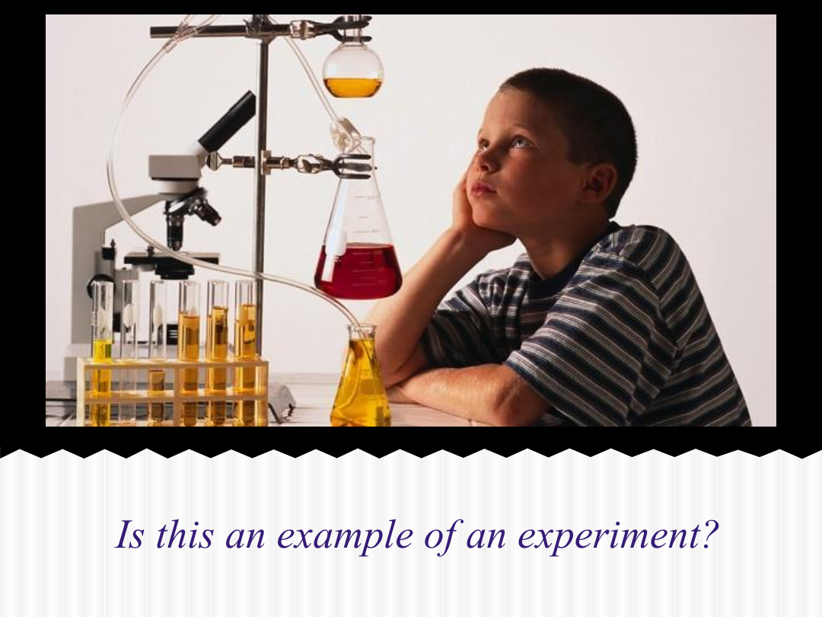
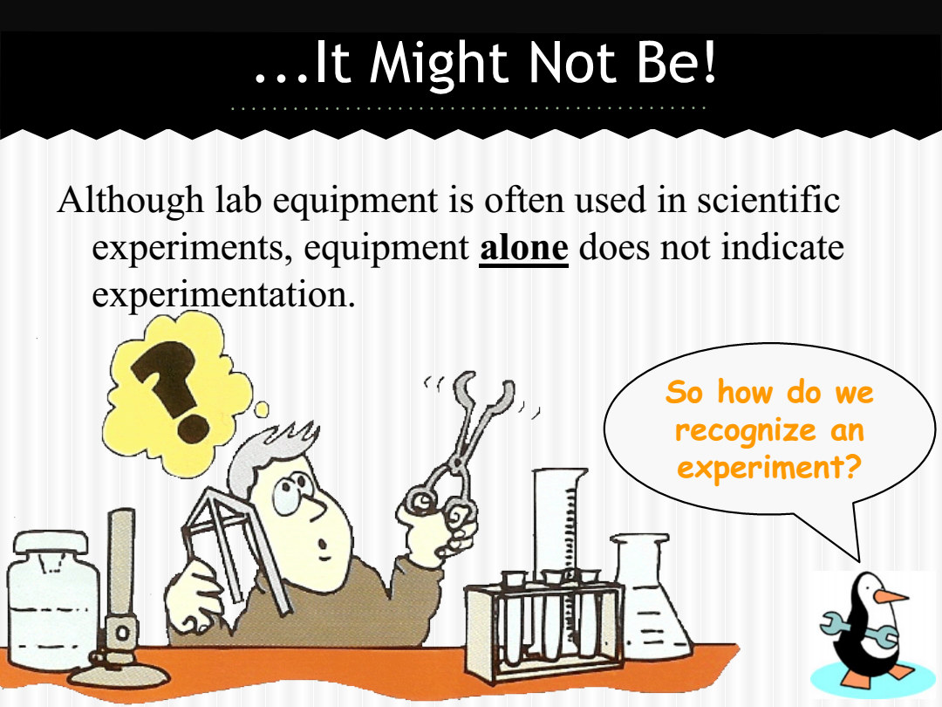
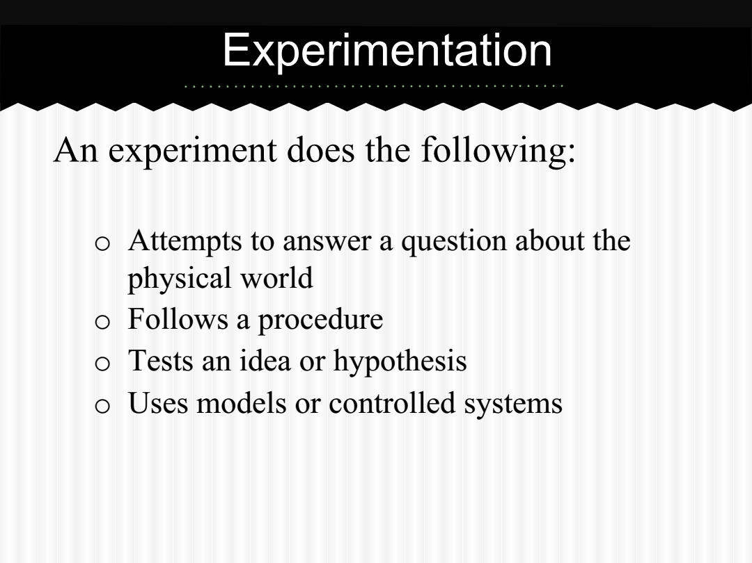
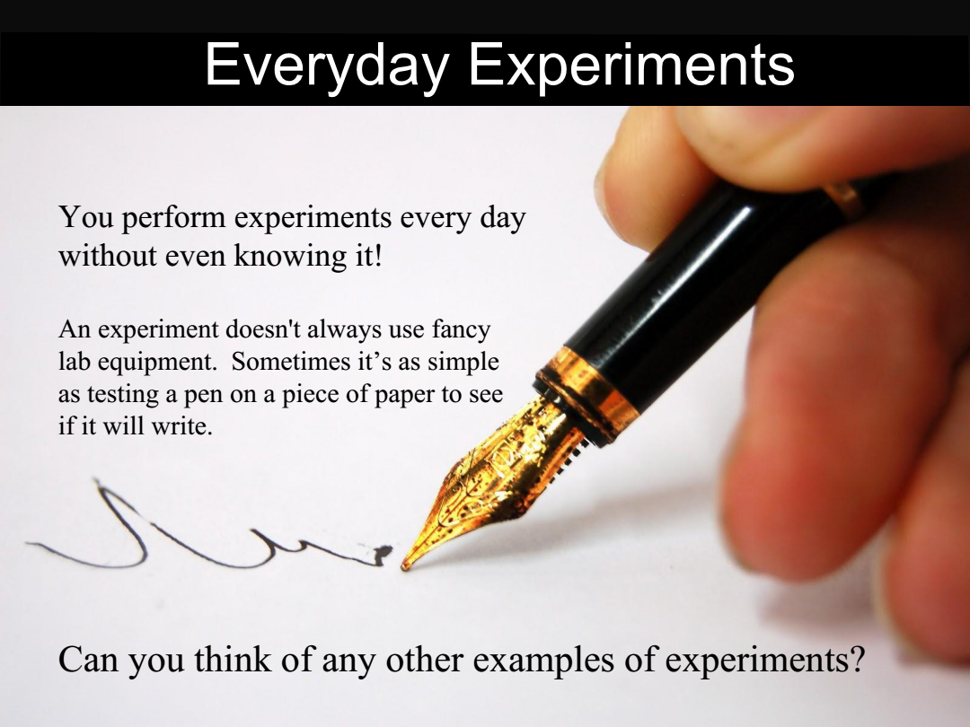
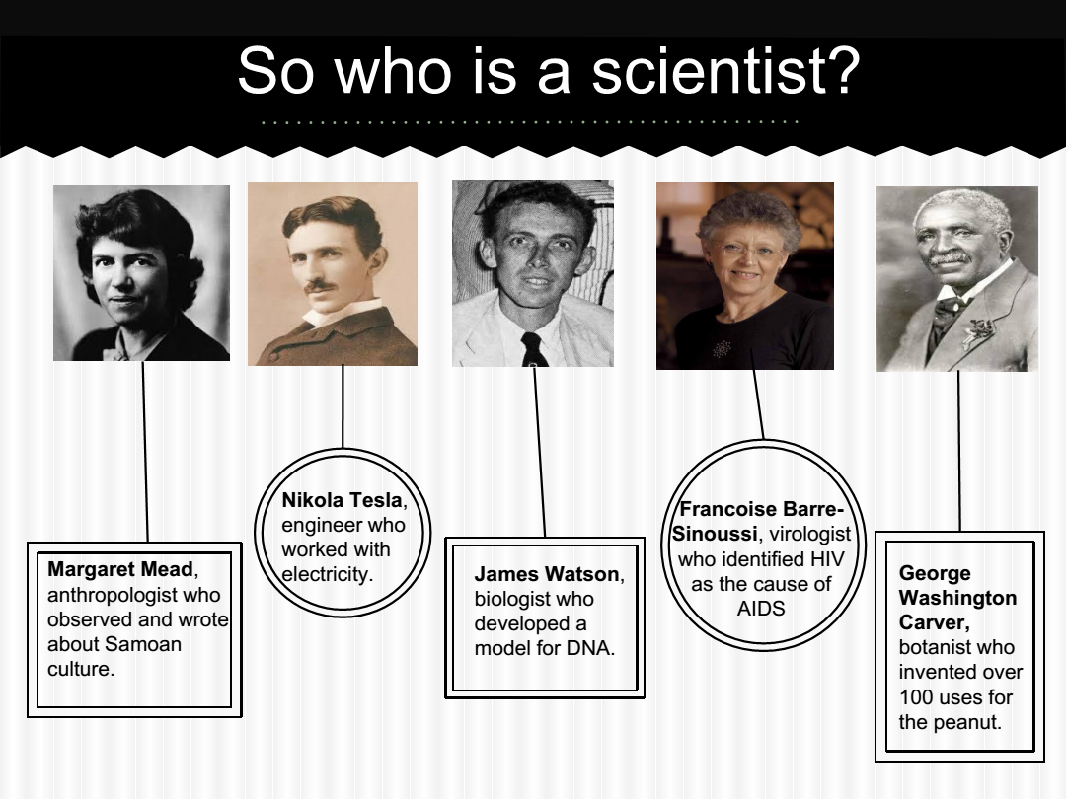
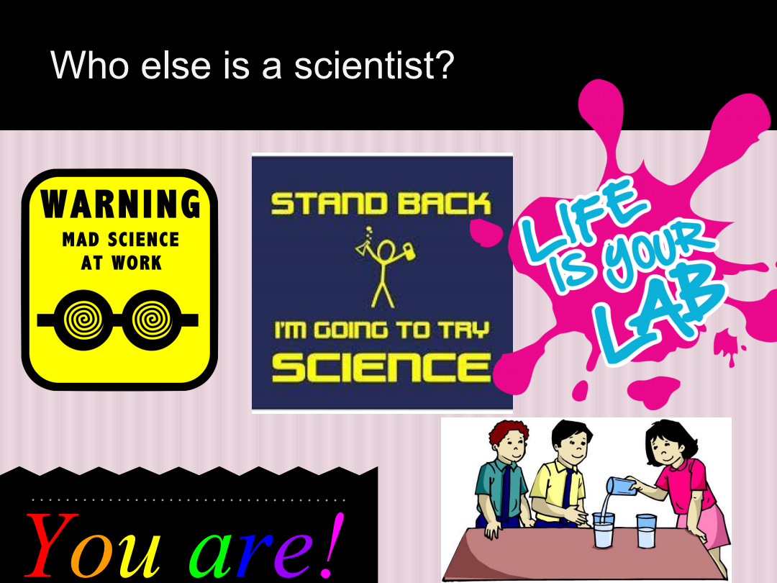
Order the Scientific Method

Number the following steps of the scientific method in the order that you think they should be carried out.

MAKE OBSERVATIONS / COLLECT DATA
During the course of the experiment, you will make observations about what is happening and collect numerical data to help you see relationships, trends, and comparisons.

ASK A QUESTION
Look at the problem you are trying solve or the event you are trying to understand and formulate a question that can get a solution. This step is the most important as asking the right question is more likely to lead you to the right answer.

DRAW A CONCLUSION
Look at the data to see if you have found new clues. Depending on the data you may find evidence that proves or disproves your hypothesis. Remember, a good experiment allows you to draw a conclusion about the hypothesis, whether valid or invalid. A correct hypothesis does not necessarily make a good hypothesis.

COMMUNICATE YOUR RESULT
The scientific community is all about sharing your knowledge, so the final step of the scientific method is to let others know what you have learned! You can do this by making a presentation or simply by telling your neighbor what you have found.

EXPERIMENT
Test your hypothesis in a setting with variables and controls. An experiment follows a procedure that can be tested multiple times.

CONSTRUCT A HYPOTHESIS
This is your initial explanation of the answer to your question. Based on personal experience or background research, you can make an informed guess about the answer to your question.

Steps of the Scientific Method

ASK A QUESTION
Look at the problem you are trying solve or the event you are trying to understand and formulate a question that can get a solution. This step is the most important as asking the right question is more likely to lead you to the right answer.

CONSTRUCT A HYPOTHESIS
This is your initial explanation of the answer to your question. Based on personal experience or background research, you can make an informed guess about the answer to your question.

EXPERIMENT
Test your hypothesis in a setting with variables and controls. An experiment follows a procedure that can be tested multiple times.

MAKE OBSERVATIONS / COLLECT DATA
During the course of the experiment, you will make observations about what is happening and collect numerical data to help you see relationships, trends, and comparisons.

DRAW A CONCLUSION
Look at the data to see if you have found new clues. Depending on the data you may find evidence that proves or disproves your hypothesis. Remember, a good experiment allows you to draw a conclusion about the hypothesis, whether valid or invalid. A correct hypothesis does not necessarily make a good hypothesis.

COMMUNICATE YOUR RESULT
The scientific community is all about sharing your knowledge, so the final step of the scientific method is to let others know what you have learned! You can do this by making a presentation or simply by telling your neighbor what you have found.

It’s time to be a scientist now! HAVE FUN!

