Adaptation and Behavior

Lesson #7: How Does Adaptation Happen?
Adaptation Simulation
Adapted from an activity called “Evolution by Natural Selection” (2006) by Maureen Jenner, Community School, Sun Valley,by Jennifer Doherty and Dr. Ingrid Waldron, Department of Biology, University of Pennsylvania.

Time Frame: 2 hours (or more depending on how this activity is run). This activity will be divided into two parts with the simulation one day and the analysis on another day

Learning Standards:
Science
Life Science: Plant (and Animal) Structures and Functions
- Give examples of how inherited characteristics may change over time as adaptations to changes in the environment that enable organisms to survive, e.g., shape of beak or feet, placement of eyes on head, length of neck, shape of teeth, color.
- Give examples of how changes in the environment (drought, cold) have caused some plants and animals to die or move to new locations (migration).
Skills of Inquiry
- Ask questions and make predictions that can be tested.
- Select and use appropriate tools and technology in order to extend observations.
- Keep accurate records while conducting simple investigations or experiments.
- Recognize simple patterns in data and use data to create a reasonable explanation for the results of an investigation of experiment.
- Record data and communicate findings to others using graphs, charts, maps, models, and oral and written reports.
Math
Data Analysis, Statistics, and Probability
- 5.D.2 Construct and interpret line plots, line graphs, and bar graphs. Interpret and label circle graphs.
Number Sense and Operations
- 6.N.9 Select and use appropriate operations to solve problems involving addition, subtraction, multiplication, division, and positive integer exponents with whole numbers, and with positive fractions, mixed numbers, decimals, and percents.

Student will be able to:
- Explain how living things become adapted to their environment over time.
- Run an adaptation simulation, record, graph, and analyze the results, and make future predictions based on habitat changes.

Resources and Materials:

Item | Amount
Science journals
Teacher simulation chart | (in binder)
Adaptation simulation chart overhead | (in binder)
Student adaptation simulation predictions, pom pom record sheets, data charts, graphs, and analysis questions | 25 (in bin)
Calculators | (in classroom)
Timer or clock | (in classroom)
Red faux fur fabric | 1 piece (in bin)
Black furry fleece fabric | 1 piece (in bin)
Red pom poms | 200 (in bin)
Black pom poms | 200 (in bin)
White pom poms | 200 (in bin)
Plastic forks | 24 (in bin)
Plastic spoons | 24 (in bin)
Plastic knives | 24 (in bin)
Cups | 30 (in bin)
Cactus and deer extension activity | 25 (in bin)

General Teacher Background Information:
Living things that are well adapted to their environment survive and reproduce. Those that are not well adapted don’t survive and reproduce. An adaptation is any inherited trait that increases the ability of the living things to survive and reproduce. Over many generations heritable adaptive traits become more common in a population. This process is called evolution by natural selection. Evolution by natural selection takes place over many, many generations.
Evolution by natural selection leads to adaptation within a population. The term evolution by natural selection does not refer to individuals changing, only to changes in the frequency of adaptive traits in the population as a whole.
In summary, a heritable trait that helps a living thing have more offspring which survive to reproduce will tend to become more common in a population as a result of evolution by natural selection.

Lesson #7 Part I - Simulation:

Focus Activity: In their science notebooks, ask students to write 3 ways that prey can avoid or fight against predators. Then discuss a few options as a class. Possibilities may include:
Hiding: camouflage, hard exterior / shell, small size
Intimidating predator: living in large groups, lizard push-ups
Playing dead
Avoiding habitat occupied by predators
Being active at different time of day
Altering activity in response to risk

Introduction: Review adaptation ideas from past science lessons. How do animals become adapted to their environments? Why must inherited traits be involved in adaptations? Does it take a short amount of time or long time? Explain.

Activity:
- Explain to the class that today we will play a simulation game to demonstrate how adaptation over time works. This simulation involves pom poms that can reproduce. These pom poms live out their lives on a Black Forest or Red Grassland habitat, both found in the middle of the classroom. The only concern our pompom creatures have is the presence of ravenous hunters (that’s you!).
- For adaptation over time to occur there must be three conditions (write the three conditions on the board and discuss the following details as a class using the physical props from the game to demonstrate the inherited traits):
  - Inherited traits - For adaptation over time to occur, the characteristics that affect survival and reproduction must be inherited. In our simulation, a pompom that is born into the pompom population is the same color as its parent and a hunter that is born into the hunter population has the same feeding structure as its parent.
  - Variation in inherited traits - For adaptation over time to occur, different individuals in a population must have different characteristics. Pom poms vary in color; they are black, red, and white. Hunters have three different types of feeding structures: forks, knives, and spoons.
  - Differences in survival and reproduction - For adaptation over time to occur, the different characteristics of different individuals must contribute to differences in their ability to survive and reproduce. For example, pompom color may influence the probability that a pompom is snatched up by a hungry hunter. Also, the different feeding types may vary in their success in capturing pom poms. These differences contribute to survival and therefore success in reproducing.
- Instructor will split the class into two groups which will carry out the simulation using two different habitats: Black Forest (represented by a black furry fleece fabric) and Red Grassland (represented by a red faux fur fabric). Half of the class will complete the activity on the Black Forest and half of the class will complete the activity on the Red Grassland. Pom poms come in three different colors: red, white and black.
Alternatively, if you have a small class you can complete the simulation with all of the students for the Black Forest habitat first and then complete the simulation for the Red Grassland second.
- Get student helpers to place 30 pom poms of each color on each of the habitats. So, each habitat will have 30 white pom poms, 30 red pom poms, and 30 black pom poms. This is your Generation 1 pompom data (already included on the teacher simulation chart provided). Record this data on the board.
- Give each student an adaptation simulation student handout and ask them to make predictions about what color pompom will survive better in each habitat.
- Then, arm the hunters and provide them with a stomach (cup) to fill. Divide the spoons, forks, and knives equally among each group of students (those hunting on the forest and those hunting on the grassland). Tell the students that they must get the pom poms into their cups using only their hunting device (not the cup or their fingers). Ask each student to make predictions about which type of hunter will survive better in each habitat.
- Instructor will record the initial numbers of each type of utensil (hunter) in each habitat on the board and in their teacher simulation chart (provided). This is your Generation 1 hunter data.
- Tell the class the signal that will indicate they should start feeding. Encourage students to compete with their fellow hunters if necessary. However, once a pompom is in a cup it is off limits. Then model calling time and ending the feeding session.
- Complete at least one (and possibly more) practice round before starting to record the data to ensure that students understand the instructions.
- Conduct the first feeding session using the start and stop signals. Give students 30 seconds (more if they have trouble collecting the pom poms) and make sure that students are using only their hunting device to get the pom poms in the cup.
- Then, ask the students to count the number of pom poms they collected of each color. Give each student a record sheet (for their habitat) and ask them to write down the number of pom poms for each color and the total number. Ask the student groups (one for each habitat) to line up according to how many pom poms they ate, from least to greatest.
- For each habitat, have the students stay in line. Start with the person with the lowest number of pom poms, and give the student that “died” the same implement as the person with the highest number of pom poms. Work your way up, matching each low person with the next person from the high end of the line. Record how many hunters of each type there are in the next generation after the implements are reassigned on the board and in the teacher simulation chart.
- Get a student volunteer from each habitat group to collect the record sheets from each person. Use the record sheets to record the class data for each habitat. For each habitat, determine how many pom poms of each color were eaten and how many remain. Write the data on the board and in the teacher simulation handout.
- Calculate the number of pom poms that need to be added to each habitat. Use the teacher simulation chart. Count out the necessary number of pom poms for each habitat and have students help reseed each location.
- Conduct the second generation of the simulation. Repeat steps 9-13. More instructions specific to the generation 2 feeding are below.
- Conduct the second feeding session using the start and stop signals. Give students 30 seconds (more if they have trouble collecting the pom poms).
- Then, ask the students to count the number of pom poms they collected of each color. Give each student a record sheet (for their habitat) and ask them to write down the number of pom poms for each color and the total number. Ask the student groups (one for each habitat) to line up according to how many pom poms they ate, from least to greatest.
- For each habitat, have the students stay in line. Start with the person with the lowest number of pom poms, and give the student that “died” the same implement as the person with the highest number of pom poms. Work your way up, matching each low person with the next person from the high end of the line. Record how many hunters of each type there are in the next generation after the implements are re-assigned. This is your Generation 3 hunter utensil data.
- Get a student volunteer from each habitat group to collect the record sheets from each person. For each habitat, determine how many pom poms of each color were eaten and how many remain and record. This is your Generation 3 pompom data.
- Have the teacher record all the data for day 2.

Closure: Lead a class discussion on the adaptation simulation. What color pom pom survived best in each environment? How does this relate to animals in real life?

Lesson #7 Part II - Analysis:

Focus Activity: In their science notebooks, ask students to write 3 ways that predators are adapted to capture prey. Then discuss a few options as a class. Possibilities may include:
Physical characteristics: speed, claws, teeth, strong jaw, physical strength, size
Behavioral characteristics: building traps (spiders), stalking prey, poison, ways to stun prey

Continuation of Activity:
- Direct students to return to their adaptation simulation student handout. Students will fill in their chart with the class data from the board. Students will use the data to make bar graphs representing the population data for the hunters and pom poms over the three generations.
- Students may complete one, 2, or all 4 of the graphs. Students may do the graphs individually, in groups of 2 (each person does 2 of the graphs) or in groups of 4 with each person completing one of the graphs.
- Students will work in small groups to complete the adaptation simulation analysis questions in their lab notebooks. Students will use their data and graphs to answer the questions. Instructor can assist groups and ask questions about the results, how the students interpret the data, and relate the activity to adaptation over time.
- Work on the Cacti and Deer extension activity (provided) after students finish the data analysis.

Closure: Lead a class discussion on the adaptation simulation. How did this simulation represent adaptation over time? How did the pom poms adapt in the red grasslands? How did the pom poms adapt in the black forest? How did the hunters adapt in each habitat? Did individual hunters or individual pom poms adapt? Explain. How does adaptation over time explain all the differences in living things?

Extended Discussion Question: What do you think would happen to the hunter and pompom populations if the black forest experienced a decade long drought and became a red grassland? First, make your prediction of what would happen if the population of pom poms in the black forest at the beginning included red, white and black pom poms. Next, suppose that adaptation over many generations had resulted in only black pom poms surviving in the black forest, and then a long drought resulted in this habitat turning into a red grassland. What might happen? Based on this example, explain why adaptation can not occur if there is no variation in a characteristic.

Assessment: Science notebooks responses, simulation data charts, graphs, and analysis question responses, simulation activity and discussion participation

Teacher Adaptation Simulation Chart: Red Grassland

Habitat Type: Red Grassland
Pom pom Color | Red | Black | White
# in Generation 1 | 30 | 30 | 30
# Eaten in Generation 1

# Remaining in Generation 1
(30 - # eaten)
# New to add
(2 x # remaining)

# in Generation 2
(# Remaining + # New)
# Eaten in Generation 2

# Remaining in Generation 2
(# in Generation 2 - # eaten)
# New to add
(2 x # remaining)

# in Generation 3
(# Remaining + # New)

Hunter Type | Spoon | Fork | Knife
# in Generation 1

# in Generation 2

# in Generation 3

Teacher Adaptation Simulation Chart: Black Forest

Habitat Type: Black Forest
Pom pom Color | Red | Black | White
# in Generation 1 | 30 | 30 | 30
# Eaten in Generation 1

# Remaining in Generation 1
(30 - # eaten)
# New to add
(1 x # remaining)

# in Generation 2
(# Remaining + # New)
# Eaten in Generation 2

# Remaining in Generation 2
(# in Generation 2 - # eaten)
# New to add
(1 x # remaining)

# in Generation 3
(# Remaining + # New)

Hunter Type | Spoon | Fork | Knife
# in Generation 1

# in Generation 2

# in Generation 3

Adaptation Simulation Data

Pom poms (Prey)

 | Red Grassland |  |  |  | Black Forest
 | Pom poms |  |  |  | Pom poms
 | Black | Red | White | Total | Black | Red | White | Total
Number in Generation 1

Number in Generation 2

Number in Generation 3

Utensils (Hunters)

 | Red Grassland |  |  |  | Black Forest
 | Hunters |  |  |  | Hunters
 | Spoon | Fork | Knife | Total | Spoon | Fork | Knife | Total
Generation 1
Number

Generation 2
Number

Generation 3
Number

Adaptation Simulation

Prediction: Which color pompom do you think will be more likely to survive in each habitat?

Black Forest: _____________________

Red Grassland: _____________________

Why do you think that?

Prediction: Which feeding structure (fork, spoon, or knife) do you think will do better in each habitat?

Black Forest: _____________________

Red Grassland: _____________________

Why do you think that?

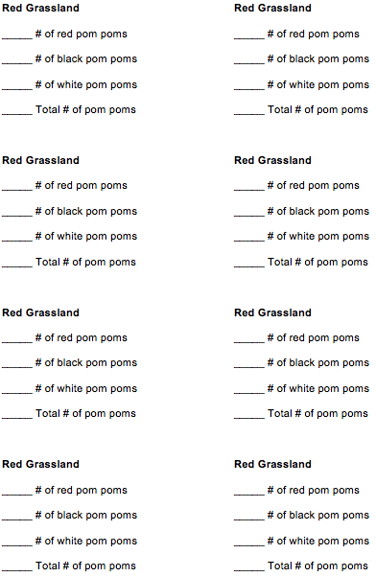
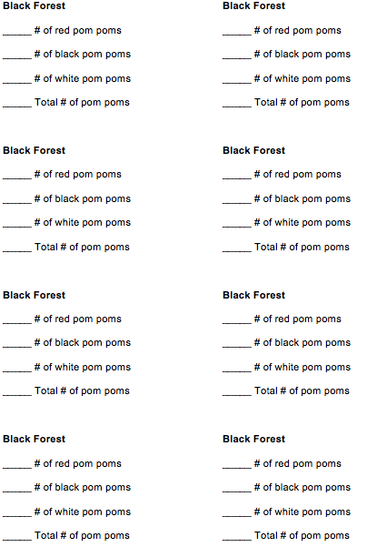
Adaptation Simulation Data

Pom poms (Prey)

 | Red Grassland |  |  |  | Black Forest
 | Pom poms |  |  |  | Pom poms
 | Black | Red | White | Total | Black | Red | White | Total
Number in Generation 1

Number in Generation 2

Number in Generation 3

Utensils (Hunters)

 | Red Grassland |  |  |  | Black Forest
 | Hunters |  |  |  | Hunters
 | Spoon | Fork | Knife | Total | Spoon | Fork | Knife | Total
Generation 1
Number

Generation 2
Number

Generation 3
Number

Data Analysis

Create a bar graph (using the graph outlines provided) to show how the numbers of the different types of pom poms and hunters (utensils) changed over the generations for each habitat. Use your graphs to answer the analysis questions below.

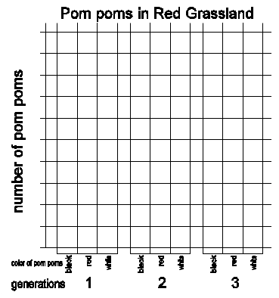

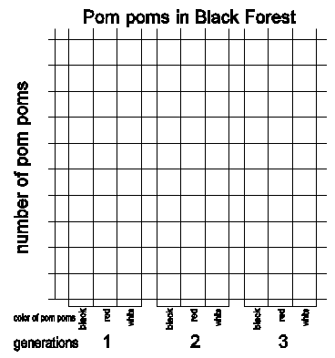

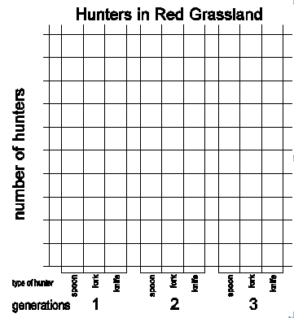

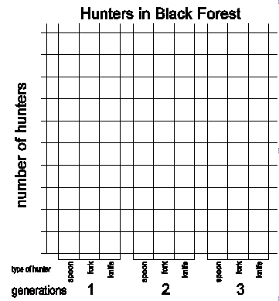

Analysis Questions

- Did adaptation occur in each pompom population? In other words, did one pompom color become more common over time while the other colors became less common? What characteristics contributed to the survival of pom poms that lived to reproduce? Remember that the pompom populations were the same on the Black Forest and Red Grassland at the beginning.

Black Forest:

Red Grassland:

- For each population of hunters, did one feeding type become more common while other feeding types became less common? What characteristics contributed to the survival of hunters that lived to reproduce?

Black Forest:

Red Grassland:

- Did any individual pom poms change color or adapt? If not, then why did the colors of the pom poms in the final population differ from the colors of the pom poms in the original populations?

- If we ran the simulation for 50 more times, what would you predict about the colors of the pom poms and the hunter types in each habitat?

Black Forest:

Red Grassland:

Cacti and Deer

Tying it all together: Look at the series of pictures below. They represent changes in a population of cacti over many generations.

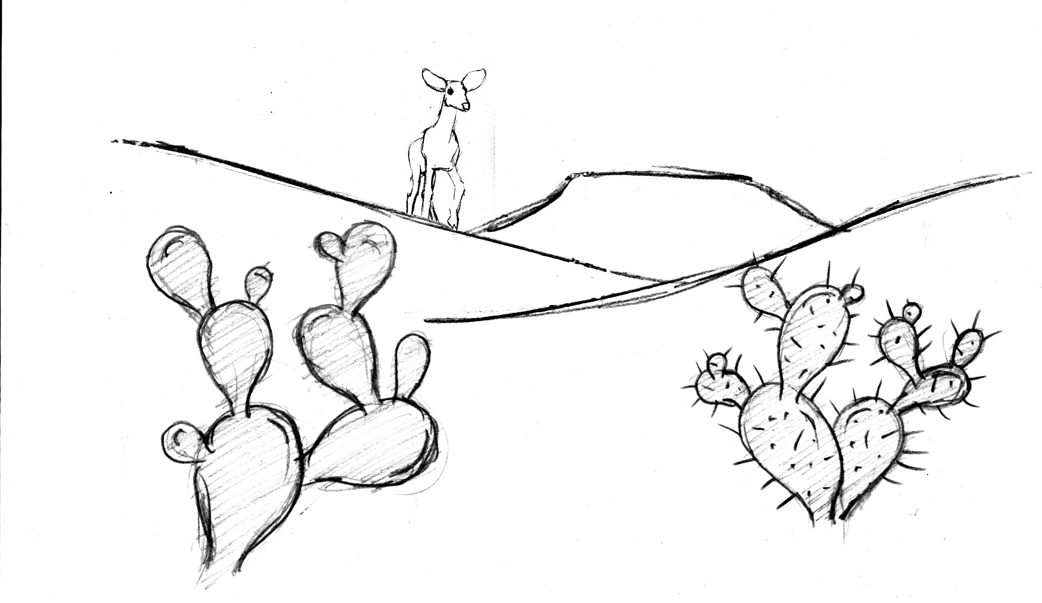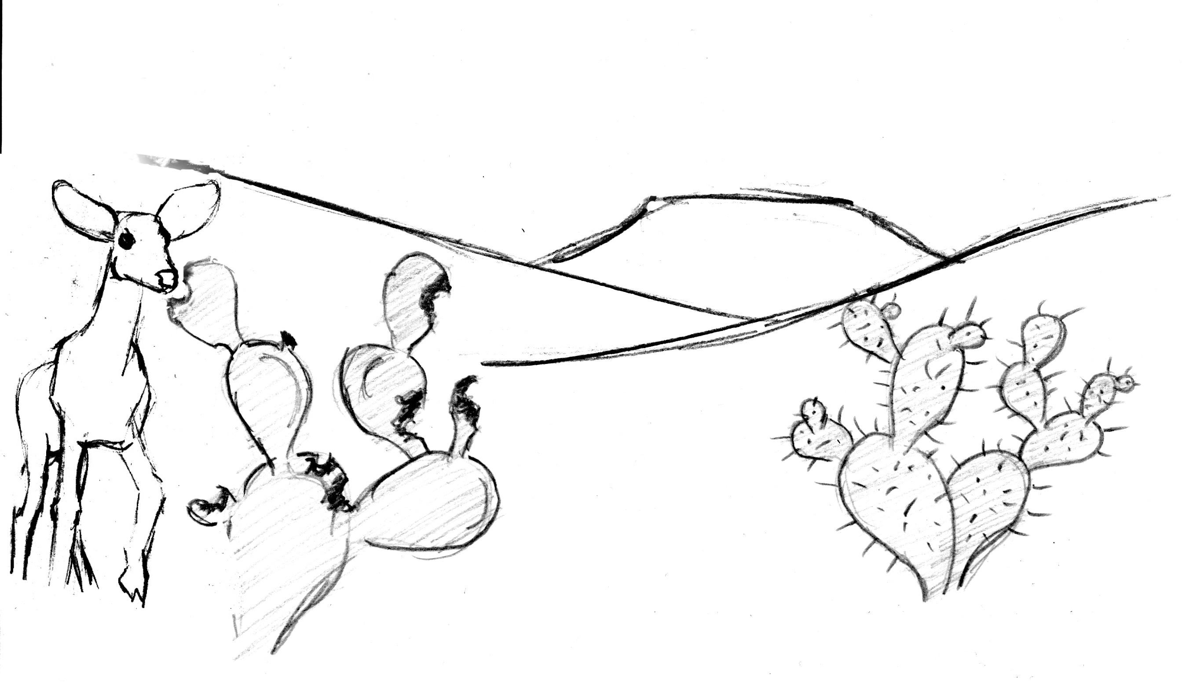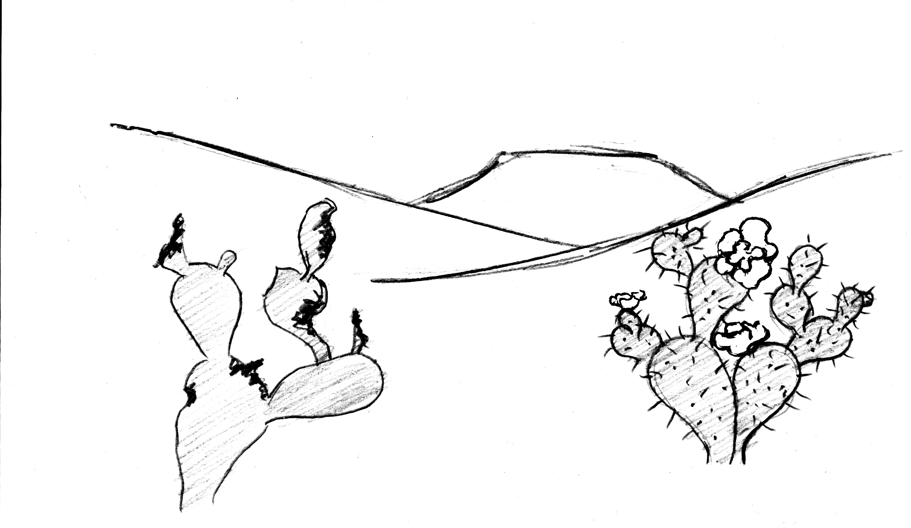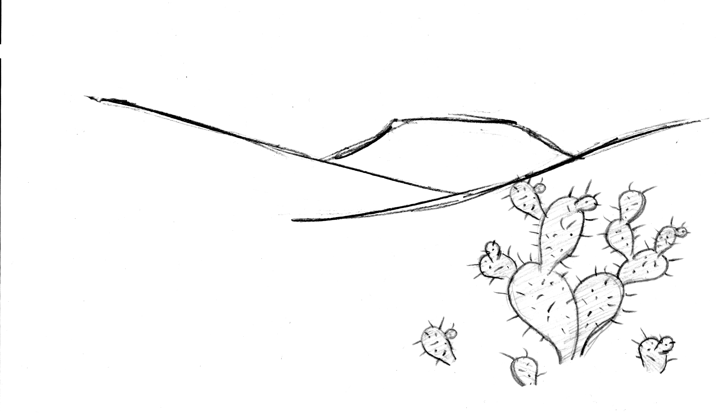
4
3
2
1

- Why would a deer be more likely to eat the left cactus than the right cactus?

- In figure 3, the cactus on the right has flowers, but the cactus that has been eaten by the deer is too damaged to make flowers. Figure 4 shows the situation several months later. What has happened? Do you think that adaptation over time is occurring in this cactus population? Explain why or why not.

- What adaptation seems to increase the survival and reproduction of the cacti? How do you think this adaptation increases the ability of cacti to both survive and reproduce?

